# 25G SFP28 Active optical cable

# Features：

* Electrical interface compliant to SFF-8431

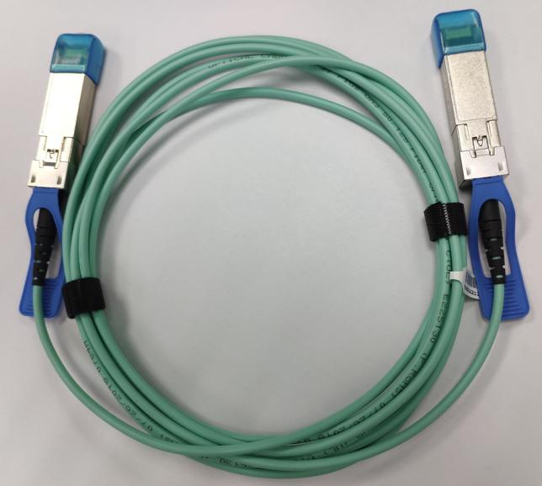

* 850nm VCSEL laser and PIN photo-detector
* Maximum link length of 70m on OM3 MMF and 100m on OM4 MMF
* Digital diagnostics functions are available via the I2C interface
* Operating case temperature Commercial: 0°C to +70 °C

● +3.3V single power supply

* Power consumption less than 1W
* RoHS compliant
* Password protection for A0h and A2h

# Applications

* 25GBASE-SR Ethernet
* Servers, switches, storage and host card adapters

# Absolute Maximum Ratings

## Table1- Absolute Maximum Ratings

|  |  |  |  |  |  |  |
| --- | --- | --- | --- | --- | --- | --- |
| **Parameter** | **Symbol** | **Min.** | **Typical** | **Max.** | **Unit** | **Notes** |
| Supply Voltage | Vcc3 | -0.5 | - | +3.6 | V |  |
| Storage Temperature | Ts | -10 | - | +70 | °C |  |
| Operating Humidity | RH | +5 | - | +85 | % | 1 |

Note: 1 No condensation

# Recommended Operating Conditions

|  |  |  |  |  |  |  |
| --- | --- | --- | --- | --- | --- | --- |
| **Parameter** | **Symbol** | **Min.** | **Typical** | **Max.** | **Unit** | **Notes** |
| Operating Case Temperature | TC | 0 | - | +70 | °C |  |
| Power Supply Voltage | Vcc | 3.14 | 3.3 | 3.47 | V |  |
| Power Supply Current | Icc | - | - | 300 | mA |  |
| Power Dissipation | Pd | - | - | 1.0 | W |  |
| Bit Rate | BR | 8.5 | 25.78125 | - | Gbps |  |
| Fiber Bend Radius | Rb | 3 | - | - | cm |  |

## Table 2- Recommended operating Conditions

**Electrical Characteristics**

**Table 3- Electrical Characteristics**

|  |  |  |  |  |  |  |  |  |  |  |
| --- | --- | --- | --- | --- | --- | --- | --- | --- | --- | --- |
| **Parameter** | | | **Symbol** | | **Min.** | **Typ.** | **Max.** | **Units** | | **Notes** |
| **Transmitter** | | | | | | | | | | |
| Differential Data Input Swing | | | Vin,P-P | | 200 | - | 1600 | | mVPP |  |
| Input Differential Impedance | | | ZIN | | 90 | 100 | 110 | | Ω |  |
| Tx_Fault | Normal Operation | | VOL | | 0 | - | 0.8 | | V |  |
| Transmitter Fault | | VOH | | 2.0 | - | VCC | | V |  |
| Tx_Disable | Normal Operation | | VIL | | 0 | - | 0.8 | | V |  |
| Laser Disable | | VIH | | 2.0 | - | VCC+0.3 | | V |  |
| **Receiver** | | | | | | | | | | |
| Differential Date Output | | | | Vout | 400 | - | 800 | mV | |  |
| Output Differential Impedance | | | | ZD | 90 | 100 | 110 | Ω | |  |
| Rx_LOS | | Normal Operation | | VOL | 0 | - | 0.8 | V | |  |
| Lose Signal | | VoH | 2.0 | - | VCC | V | |  |

**Optical Characteristics**

**Table 4-Optical Characteristics**

|  |  |  |  |  |  |  |
| --- | --- | --- | --- | --- | --- | --- |
| **Parameter** | **Symbol** | **Unit** | **Min** | **Typ** | **Max** | **Notes** |
| **Optical transmitter Characteristics** | | | | | | |
| Bit Rate | BR | Gbps | 8.5 | 25.78125 | - |  |
| Center Wavelength Range | λc | nm | 820 | 850 | 880 |  |
| Average Launch power  Tx_off | Poff | dBm | - | - | -45 |  |
| Launch Optical Power | P0 | dBm | -6.0 |  | 2.4 | 1 |
| Extinction Ratio | ER | dB | 2 | - | - |  |
| Spectral Width(RMS) | RMS | nm | - | - | 0.65 |  |
| **Optical Receiver Characteristics** | | | | | | |
| Bit Rate | BR | Gbps | 8.5 | 25.78125 |  |  |
| Bit Error Rate | BER |  | - | - | E-12 |  |
| Damage threshold | DT | dBm | 3.4 | - | - |  |

|  |  |  |  |  |  |  |
| --- | --- | --- | --- | --- | --- | --- |
| Overload Input Optical  Power | PIN | dBm | 2.4 | - | - | 2 |
| Center Wavelength Range | λc | nm | 820 | - | 880 |  |
| Receiver Sensitivity in  Average Power | Sen | dBm | - | - | -5.2 | 3 |
| Los Assert | LosA | dBm | -30 | - | - |  |
| Los De-Assert | LosD | dBm | - | - | -13 |  |
| Los Hysteresis | LosH | dB | 0.5 |  |  |  |

Note:

1. **Coupled into 50/125 MMF.**
2. **Measured with PRBS 231-1 test pattern @25.78125Gbps.BER=E-12 3. BER=1x10-12; [PRBS231-1@25.78125Gbps.](mailto:PRBS231-1@25.78125Gbps)**

# Recommended Host Board Power Supply Circuit

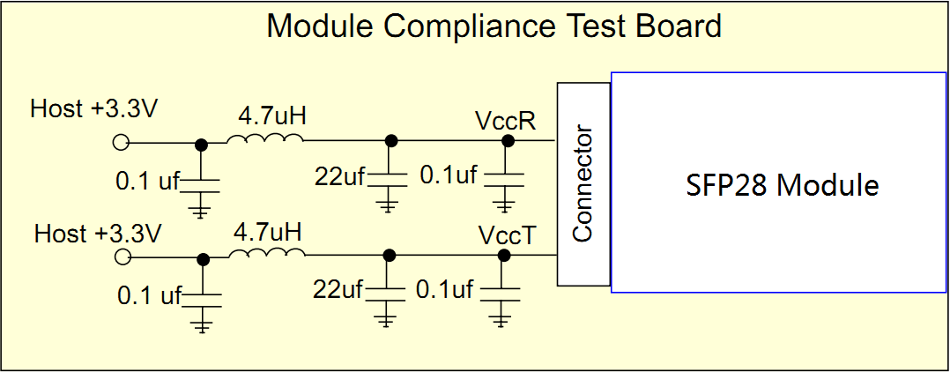

Figure 1, Recommended Host Board Power Supply Circuit

# Recommended Interface Circuit

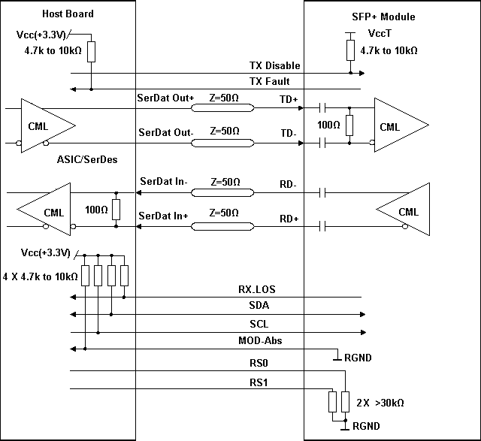

Figure 2, Recommended Interface Circuit

# Pin arrangement

## Table 5-Pin Function Definitions

Figure 3, Pin View

|  |  |  |  |
| --- | --- | --- | --- |
| **Pin** | **Symbol** | **Name/Description** | **Notes** |
| 1 | VEET | Module Transmitter Ground | 1 |
| 2 | TX_FAULT | Module Transmitter Fault | 2 |
| 3 | TX_DISABLE | Transmitter Disable; Turns off transmitter laser output | 3 |
| 4 | SDA | 2-Wire Serial Interface Data Line (MOD-DEF2) |  |
| 5 | SCL | 2-Wire Serial Interface Clock (MOD-DEF1) |  |
| 6 | MOD_ABS | Module Absent, connected to VEET or VEER in the module | 2 |
| 7 | RS0 | Rate Select 0, optionally controls SFP+ module receiver | 4 |
| 8 | RX_LOS | Receiver Loss of Signal Indication (In FC designated as Rx_LOS and in Ethernet designated as NOT Signal Detect) | 2 |
| 9 | RS1 | Rate Select 1, optionally controls SFP+ module transmitter | 4 |
| 10 | VEER | Module Receiver Ground | 1 |
| 11 | VEER | Module Receiver Ground | 1 |
| 12 | RD- | Receiver Inverted Data Output |  |
| 13 | RD+ | Receiver Non-Inverted Data Output |  |
| 14 | VEER | Module Receiver Ground | 1 |
| 15 | VCCR | Module Receiver 3.3 V Supply |  |
| 16 | VCCT | Module Transmitter 3.3 V Supply |  |
| 17 | VEET | Module Transmitter Ground | 1 |
| 18 | TD+ | Transmitter Non-Inverted Data Input |  |
| 19 | TD- | Transmitter Inverted Data Input |  |
| 20 | VEET | Module Transmitter Ground | 1 |

Note:

1. **The module ground pins are isolated from the module case.**
2. **The pins shall be pulled up with 4.7K-10Kohms to a voltage between 3.14V and 3.46V on host board.**
3. **The pin is pulled up to VCCT with a 4.7K-10KΩ resistor in the module.**
4. **See SFF-8472 Rev12.2 Table 10-2.**

# Monitoring Specification

Figure 4, Memory Map

**Mechanical Design Diagram**

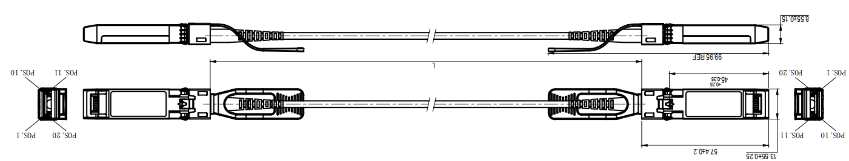

**Table 5- Cable Length**

|  |  |
| --- | --- |
| **Cable Length L（Unit: m）** | **Tolerant（Unit: cm）** |
| ≤1.0 | +5/-0 |
| 1.0＜L≤4.5 | +15/-0 |
| 4.5＜L≤14.5 | +30/-0 |
| ＞14.5 | +2%/-0 |

**Warnings**

Handling Precautions: This device is susceptible to damage as a result of electrostatic discharge (ESD).

A static free environment is highly recommended. Follow guidelines according to proper ESD procedures.

Laser Safety: Radiation emitted by laser devices can be dangerous to human eyes. Avoid eye exposure to direct or indirect radiation.