# 40G DSFP+ Active optical cable

# Features

* Support 40GBASE-SR4/QDR application

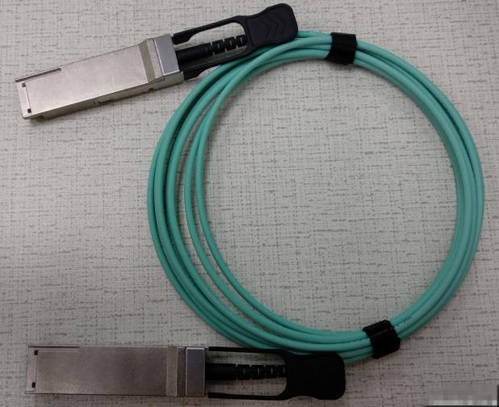

* Compliant to QSFP+ Electrical MSA SFF-8436
* Multi rate of up to 10.3125Gbps

● +3.3V single power supply

* Transmission distance up to 300m
* Low power consumption
* Operating case temp Commercial: 0°C to +70 °C
* UL certification cables (optional)
* RoHS compliant

# Applications

* 40GBASE-SR4 at 10.3125Gbps per lane
* InfiniBand QDR
* Other optical links

**Absolute Maximum Ratings**

**Table1- Absolute Maximum Ratings**

|  |  |  |  |  |  |  |
| --- | --- | --- | --- | --- | --- | --- |
| **Parameter** | **Symbol** | **Min.** | **Typical** | **Max.** | **Unit** | **Notes** |
| Supply Voltage | Vcc3 | -0.5 | - | +3.6 | V |  |
| Storage Temperature | Ts | -10 | - | +70 | °C |  |
| Operating Humidity | RH | +5 | - | +85 | % | 1 |

**Note: 1 No condensation**

**Recommended Operating Conditions**

**Table 2- Recommended operating Conditions**

|  |  |  |  |  |  |  |
| --- | --- | --- | --- | --- | --- | --- |
| **Parameter** | **Symbol** | **Min.** | **Typical** | **Max.** | **Unit** | **Notes** |
| Operating Case Temperature | TC | 0 | - | +70 | °C |  |
| Power Supply Voltage | Vcc | 3.14 | 3.3 | 3.47 | V |  |
| Power dissipation | Pd | - | - | 1.5 | w | 1 |
| Bit rate | BR | 1.25 | 10.3125 | - | Gbps |  |

**Note: 1 Per terminal**

**Electrical Characteristics**

**Table 3- Electrical Characteristics**

|  |  |  |  |  |  |  |  |
| --- | --- | --- | --- | --- | --- | --- | --- |
| **Parameter** | | **Symbol** | **Min.** | **Typ.** | **Max.** | **Units** | **Notes** |
| ModSelL | Module Select | VOL | 0 | - | 0.8 | V |  |
| Module Unselect | VOH | 2.5 | - | VCC | V |  |
| LPMode | Low Power Mode | VIL | 0 | - | 0.8 | V |  |
| Normal Operation | VIH | 2.5 | - | VCC+0.3 | V |  |
| ResetL | Reset | VIL | 0 | - | 0.8 | V |  |
| Normal Operation | VIH | 2.5 | - | VCC+0.3 | V |  |
| ModPrsL | Normal Operation | VOL | 0 | - | 0.4 | V |  |
| IntL | Interrupt | VOL | 0 | - | 0.4 | V |  |
| Normal Operation | VoH | 2.4 | - | VCC | V |  |
| **Electrical transmitter Characteristics** | | | | | | | |
| Differential Date Input Swing | | Vout | 200 | - | 1600 | mV |  |
| Output Differential Impedance | | ZD | 90 | 100 | 110 | Ω |  |
| **Electrical Receiver Characteristics** | | | | | | | |
| Differential Data Output Swing | | Vin,P-P | 350 | - | 800 | mVPP |  |
| Bit Error Rate | | BER |  |  | E-12 |  | 1 |
| Input Differential Impedance | | ZIN | 90 | 100 | 110 | Ω |  |

**Note: 1 PRBS2^[31-1@10.3125Gbps](mailto:31-1@10.3125Gbps)**

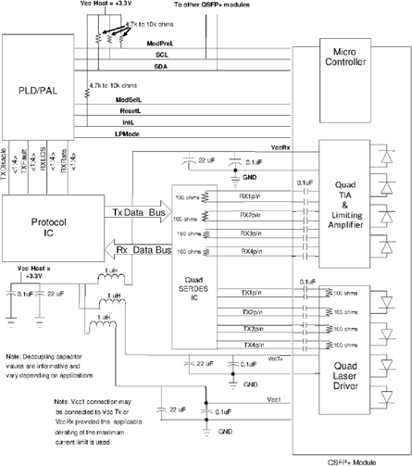**Recommended Interface Circuit**

**Figure 1, Recommended Interface Circuit**

**Pin arrangement**

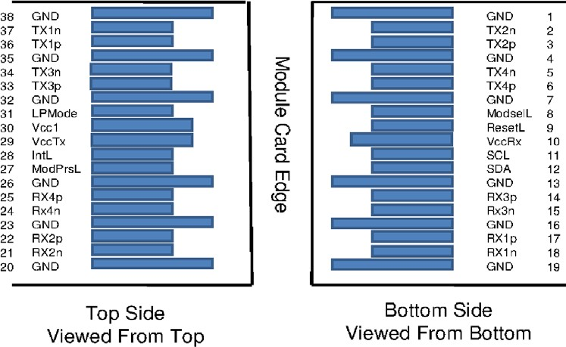

**Table 4-Pin Function Definitions**

**Figure 2, Pin View**

|  |  |  |  |
| --- | --- | --- | --- |
| **Pin** | **Symbol** | **Name/Description** | **Notes** |
| 1 | GND | Ground | 1 |
| 2 | Tx2n | Transmitter Inverted Data Input |  |
| 3 | Tx2p | Transmitter Non-Inverted Data Input |  |
| 4 | GND | Ground | 1 |
| 5 | Tx4n | Transmitter Inverted Data Input |  |
| 6 | Tx4p | Transmitter Non-Inverted Data Input |  |
| 7 | GND | Ground | 1 |
| 8 | ModSelL | Module Select |  |
| 9 | ResetL | Module Reset |  |
| 10 | Vcc Rx | +3.3V Power Supply Receiver |  |
| 11 | SCL | 2-wire serial interface clock |  |
| 12 | SDA | 2-wire serial interface data |  |
| 13 | GND | Ground | 1 |
| 14 | Rx3p | Receiver Non-Inverted Data Output |  |
| 15 | Rx3n | Receiver Inverted Data Output |  |
| 16 | GND | Ground | 1 |
| 17 | Rx1p | Receiver Non-Inverted Data Output |  |
| 18 | Rx1n | Receiver Inverted Data Output |  |
| 19 | GND | Ground | 1 |
| 20 | GND | Ground | 1 |
| 21 | Rx2n | Receiver Inverted Data Output |  |
| 22 | Rx2p | Receiver Non-Inverted Data Output |  |
| 23 | GND | Ground | 1 |
| 24 | Rx4n | Receiver Inverted Data Output |  |
| 25 | Rx4p | Receiver Non-Inverted Data Output |  |
| 26 | GND | Ground | 1 |

|  |  |  |  |
| --- | --- | --- | --- |
| 27 | ModPrsL | Module Present |  |
| 28 | IntL | Interrupt |  |
| 29 | Vcc Tx | +3.3V Power supply transmitter |  |
| 30 | Vcc1 | +3.3V Power supply |  |
| 31 | LPMode | Low Power Mode |  |
| 32 | GND | Ground | 1 |
| 33 | Tx3p | Transmitter Non-Inverted Data Input |  |
| 34 | Tx3n | Transmitter Inverted Data Input |  |
| 35 | GND | Ground | 1 |
| 36 | Tx1p | Transmitter Non-Inverted Data Input |  |
| 37 | Tx1n | Transmitter Inverted Data Input |  |
| 38 | GND | Ground | 1 |

**Note: 1. Circuit ground is internally isolated from chassis ground.**

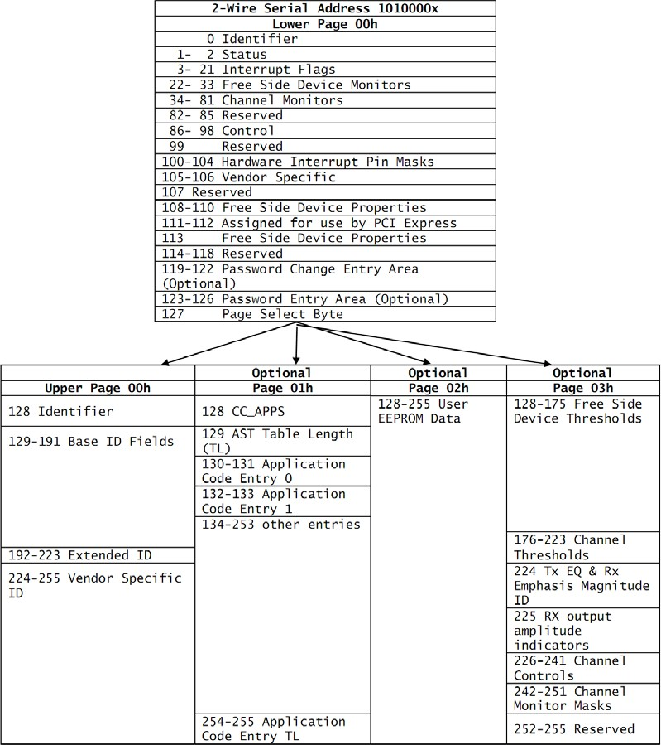**Monitoring Specification**

**Figure 3, Memory Map**

**Mechanical**

**Unit mm**

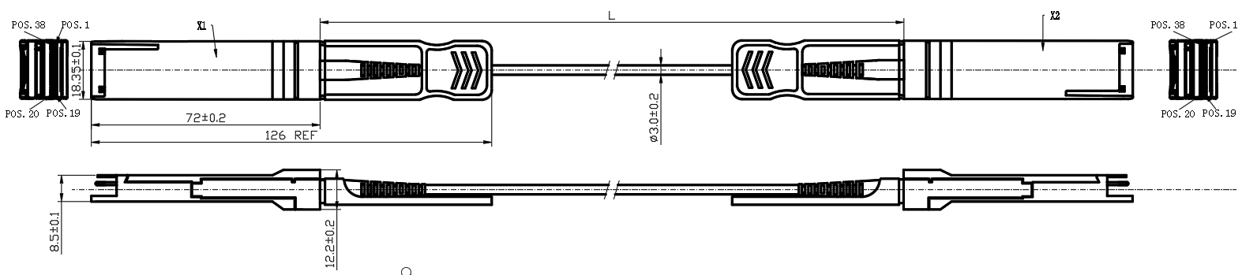

**Table 5- Cable Length**

**Figure 4, Mechanical Diagram**

|  |  |
| --- | --- |
| **Cable Length L（Unit: m）** | **Tolerant（Unit: cm）** |
| ≤1.0 | +5/-0 |
| 1.0＜L≤4.5 | +15/-0 |
| 4.5＜L≤14.5 | +30/-0 |
| ＞14.5 | +2%/-0 |

**Warnings**

**Handling Precautions:** This device is susceptible to damage as a result of electrostatic discharge (ESD).

A static free environment is highly recommended. Follow guidelines according to proper ESD procedures.

**Laser Safety:** Radiation emitted by laser devices can be dangerous to human eyes. Avoid eye exposure to direct or indirect radiation.